Twos’ Complement and Boolean Operators

Two’s Complement
Two’s Complement Representation: Negative integers use two’s-complement representation, (If you add a number to its additive inverse, the sum is zero.)
Two’s-complement representation is useful to processor designers because it removes the need for separate digital circuits to handle both addition and subtraction. For example, if presented with the expression A – B, the processor can simply convert it to an addition expression: A + (–B).
Using the 8-bit binary value 00000001, for example, its two’s complement turns out to be 11111111, as can be seen as follows:
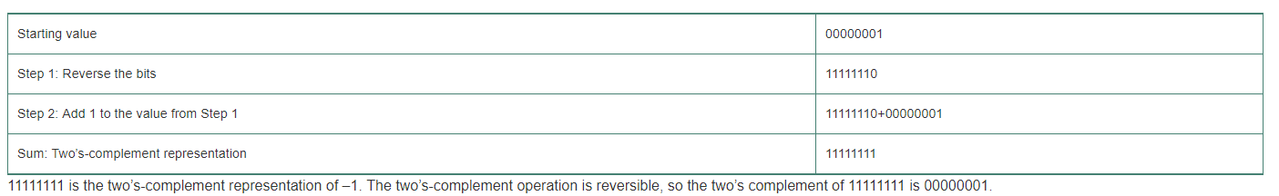
- What is the two’s complement for 01111011?
10000100 + 1 = 10000101

- What is the two’s complement for 01010101?
10101010 + 1 = 10101011

Two’s Complement for Hexadecimal Values
Hexadecimal Two’s Complement
To create the two’s complement of a hexadecimal integer, reverse all bits and add 1. An easy way to reverse the bits of a hexadecimal digit is to subtract the digit from 15. Here are examples of hexadecimal integers converted to their two’s complements:
6A3D 6-15 is 9, A or 10 -15 is 5, 3-15 is 12 or C, D or 13 – 15 is 2
- 95C2
- Then add 1 95C3

- Find the two’s complement for 118E_{16.}
EE71 + 1 = EE72

- Find the two’s complement 760B2_{16.}

Converting Signed Decimal to Hexadecimal
To convert a signed decimal integer to hexadecimal, do the following:
Step 1: Convert the absolute value of the decimal integer to hexadecimal.
Step 2: If the decimal integer was negative, create the two’s complement of the hexadecimal number from the previous step.

- Convert decimal -611 to hexadecimal.
-263 = D9C + 1 = D9D

- Convert decimal -2885 to hexadecimal.
-B45 = 4BA + 1 = 4BB

Converting Signed Hexadecimal to Decimal
To convert a signed hexadecimal integer to decimal, do the following:
Step 1: If the hexadecimal integer is negative, create its two’s complement; otherwise, retain the integer as is. Using the integer from the previous step, convert it to decimal.
Step 2: If the original value was negative, attach a minus sign to the beginning of the decimal integer.

- Convert -52A₁₆ to a decimal value.
-52A = AD5 + 1 = -AD6 = -2774

- Convert -604E₁₆ to a decimal value.
9FB1 + 1 = 9FB2 = -40882

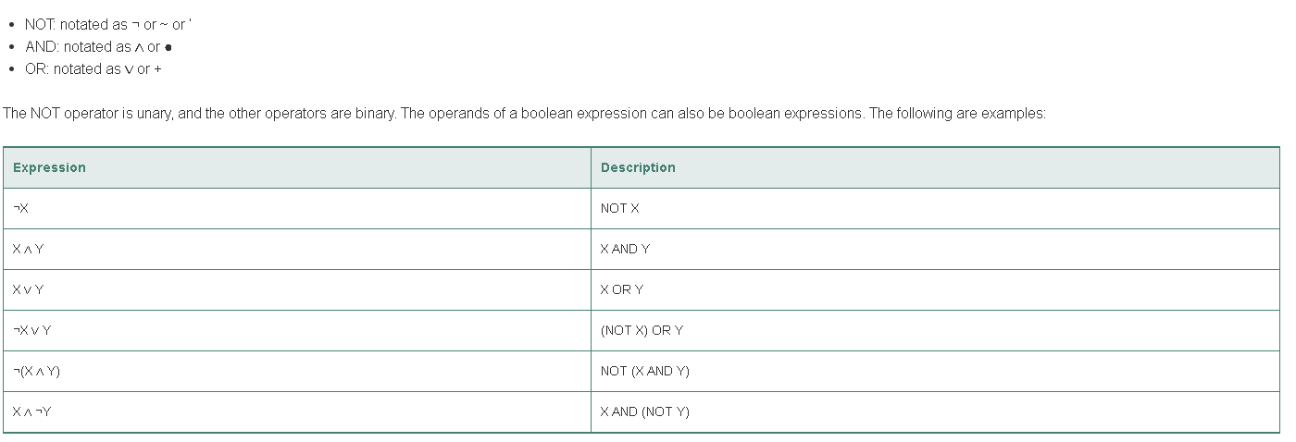
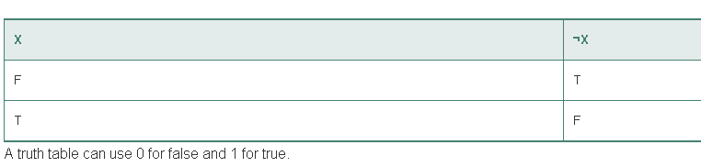
Example:
0 0 1 1 1 1 0 1
⌐1 1 0 0 0 0 1 0

- Find the NOT expression of 10101101.

01010010
- Find the NOT expression of 11111011.
00000100

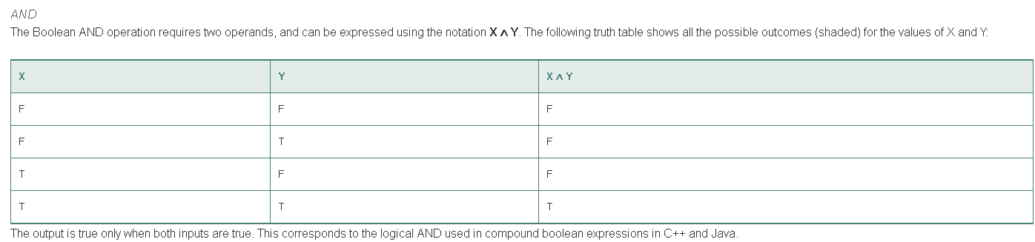
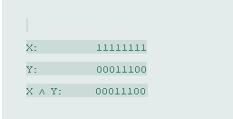
X | Y | X AND Y
0 | 0 | 0
0 | 1 | 0
1 | 0 | 0
1 | 1 | 1

- Solve:
1 0 1 1 1 0 1 1
AND 0 0 0 1 1 1 0 0
00011000

- Solve:
1 1 1 1 1 1 0 0
AND 0 0 0 1 0 1 1 0
000010100

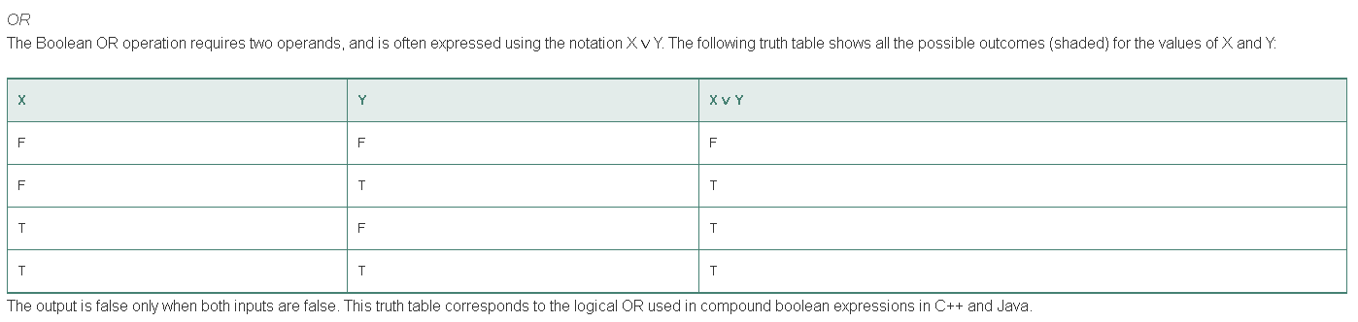
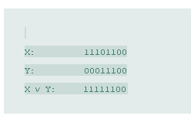
X | Y | X v Y
0 | 0 | 0
0 | 1 | 1
1 | 0 | 1
1 | 1 | 1

- Solve:
0 0 1 1 1 1 0 1
OR 1 1 1 1 1 1 0 1
111111101
- Solve:
1 0 0 1 1 1 1 0
OR 1 1 0 0 0 0 1 1
11011111

